Asia-China-Coin-Knife Money , Straight Knives -Unknown-Model Money

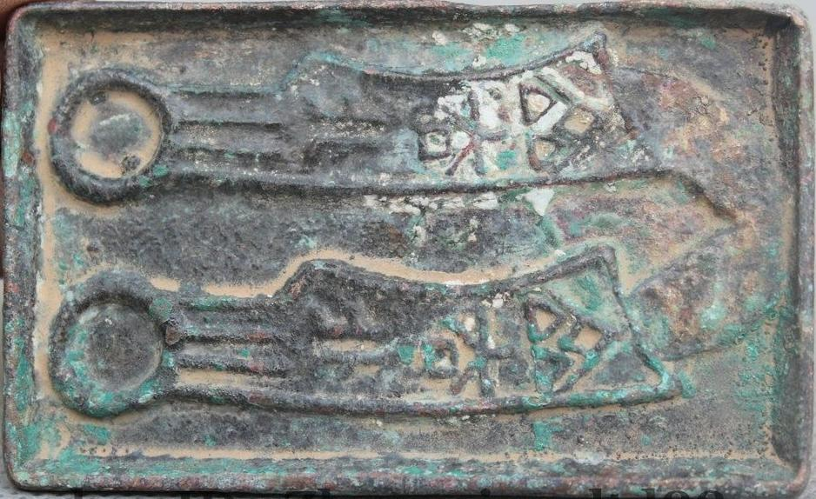

SHAPE \\* MERGEFORMAT 